Nested Hierarchical Reasoning Transformer (NHRT)
Methodology and Results Report
Base model: Qwen2.5-0.5B · Datasets: GSM8K, SVAMP, ARC-Challenge
Covers Phase 1 (architecture ablation), Phase 2 (bug fixes and extensions),
and Phase 3 (statistical validation and preference optimisation)

1. Methodology

1.1 Experimental Setup
All experiments use a single frozen base model and a fixed set of default hyperparameters unless a section explicitly states an override (e.g. the scaled-training or seed-variance runs).
Parameter | Value
Base model | Qwen/Qwen2.5-0.5B (494.0M parameters, 24 decoder layers, bfloat16)
Hidden size / attention heads | 896 hidden · 14 query heads · 2 KV heads (GQA 7:1)
Default insertion layer (TARGET_LAYER) | 12 (Phase 1 ablation winner)
Default training set size (N_TRAIN) | 200 GSM8K training examples
Default evaluation set size (N_EVAL) | 100 (Phases 1–2) → 300 from Phase 2 §2.6 onward
Epochs / learning rate | 3 epochs · 2e-4, cosine schedule with 10% warmup
Optimizer / grad clipping | AdamW, weight decay 0.01 · gradient-norm clip = 1.0
Precision | bfloat16 throughout (torch_dtype="auto") (bfloat16 avoids the loss-scaling issues float16 introduced in an earlier debugging attempt)
Datasets | GSM8K (train/test), SVAMP (test, zero-shot transfer), ARC-Challenge (test)
Table 1.1 — Fixed experimental configuration used across all phases.

1.2 Reasoning Module Architectures
Four trainable reasoning-module designs were implemented and compared, all inserted via the same gated-residual mechanism (Section 1.3).
Module | Mechanism | Trainable params (single layer)
HRB (HierarchicalReasoningBlock) | Gated blend of a shallow “fast” path and a 2-layer “deep” path, blended by a learned sigmoid controller | ~8.84M
DeepReasoner | Universal-Transformer-style iterative residual loop, fixed steps=3, RMSNorm-stabilised | ~1.61M
AdaptiveDeepReasoner (ACT) | Same iterative residual block, but each token learns its own halting probability (Graves 2016); ponder cost added to the loss | ~1.61M + halting head
DeepReasoner + LoRA (joint) | DeepReasoner spliced into a layer whose projections are also LoRA-adapted (r=16); both trained jointly | ~1.98M combined
Table 1.2 — Reasoning module designs, in order of introduction.
A fifth module, NestedReasoningModule (three parallel linear branches + aggregation), was defined for ablation completeness in Phase 1 but was superseded by HRB before any training run and does not appear in the results.

1.3 Core Mechanism: the Gated NestedDecoderLayer
Every reasoning module above is inserted into a target decoder layer using the same wrapper, shown in Figure 1.1. The base model's attention and MLP sublayers remain completely frozen; only the reasoning module and a single learnable scalar gate (initialised at 0.05, i.e. near-zero) are trained. This means the model is mathematically near-identical to the frozen baseline at initialisation, and training only opens the gate if the reasoning module's output is actually useful for the loss.
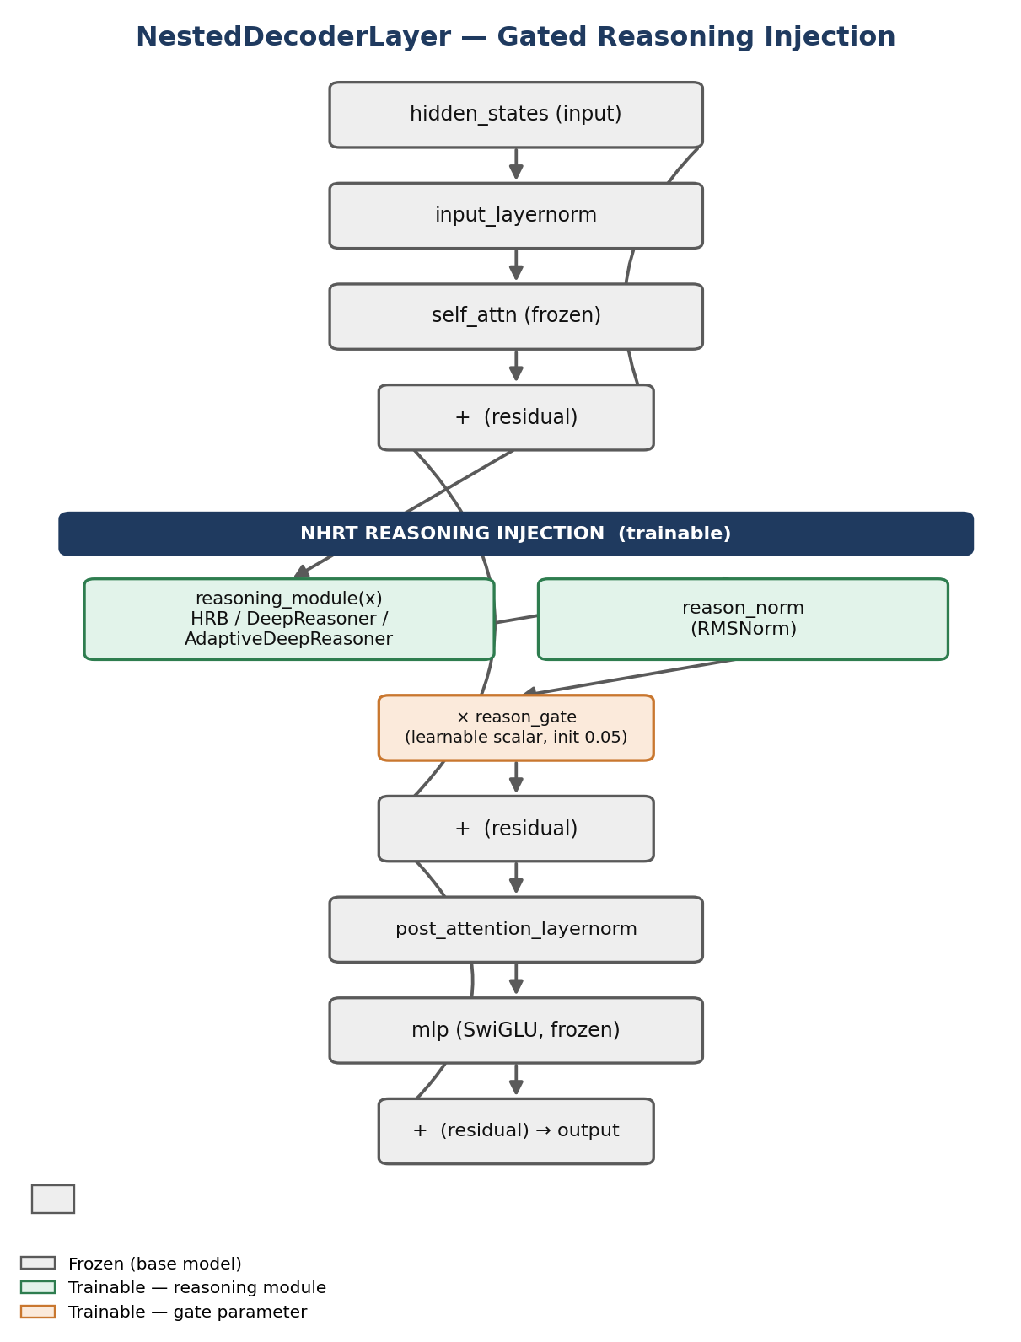
Figure 1.1 — Forward pass of NestedDecoderLayer. Gray = frozen; green = trainable reasoning module; orange = trainable gate.

1.4 Overall Research Workflow
Figure 1.2 maps every experiment across all three phases to the stage of the pipeline it belongs to. This is the master reference for how Sections 2.1–4.13 relate to one another chronologically and methodologically.
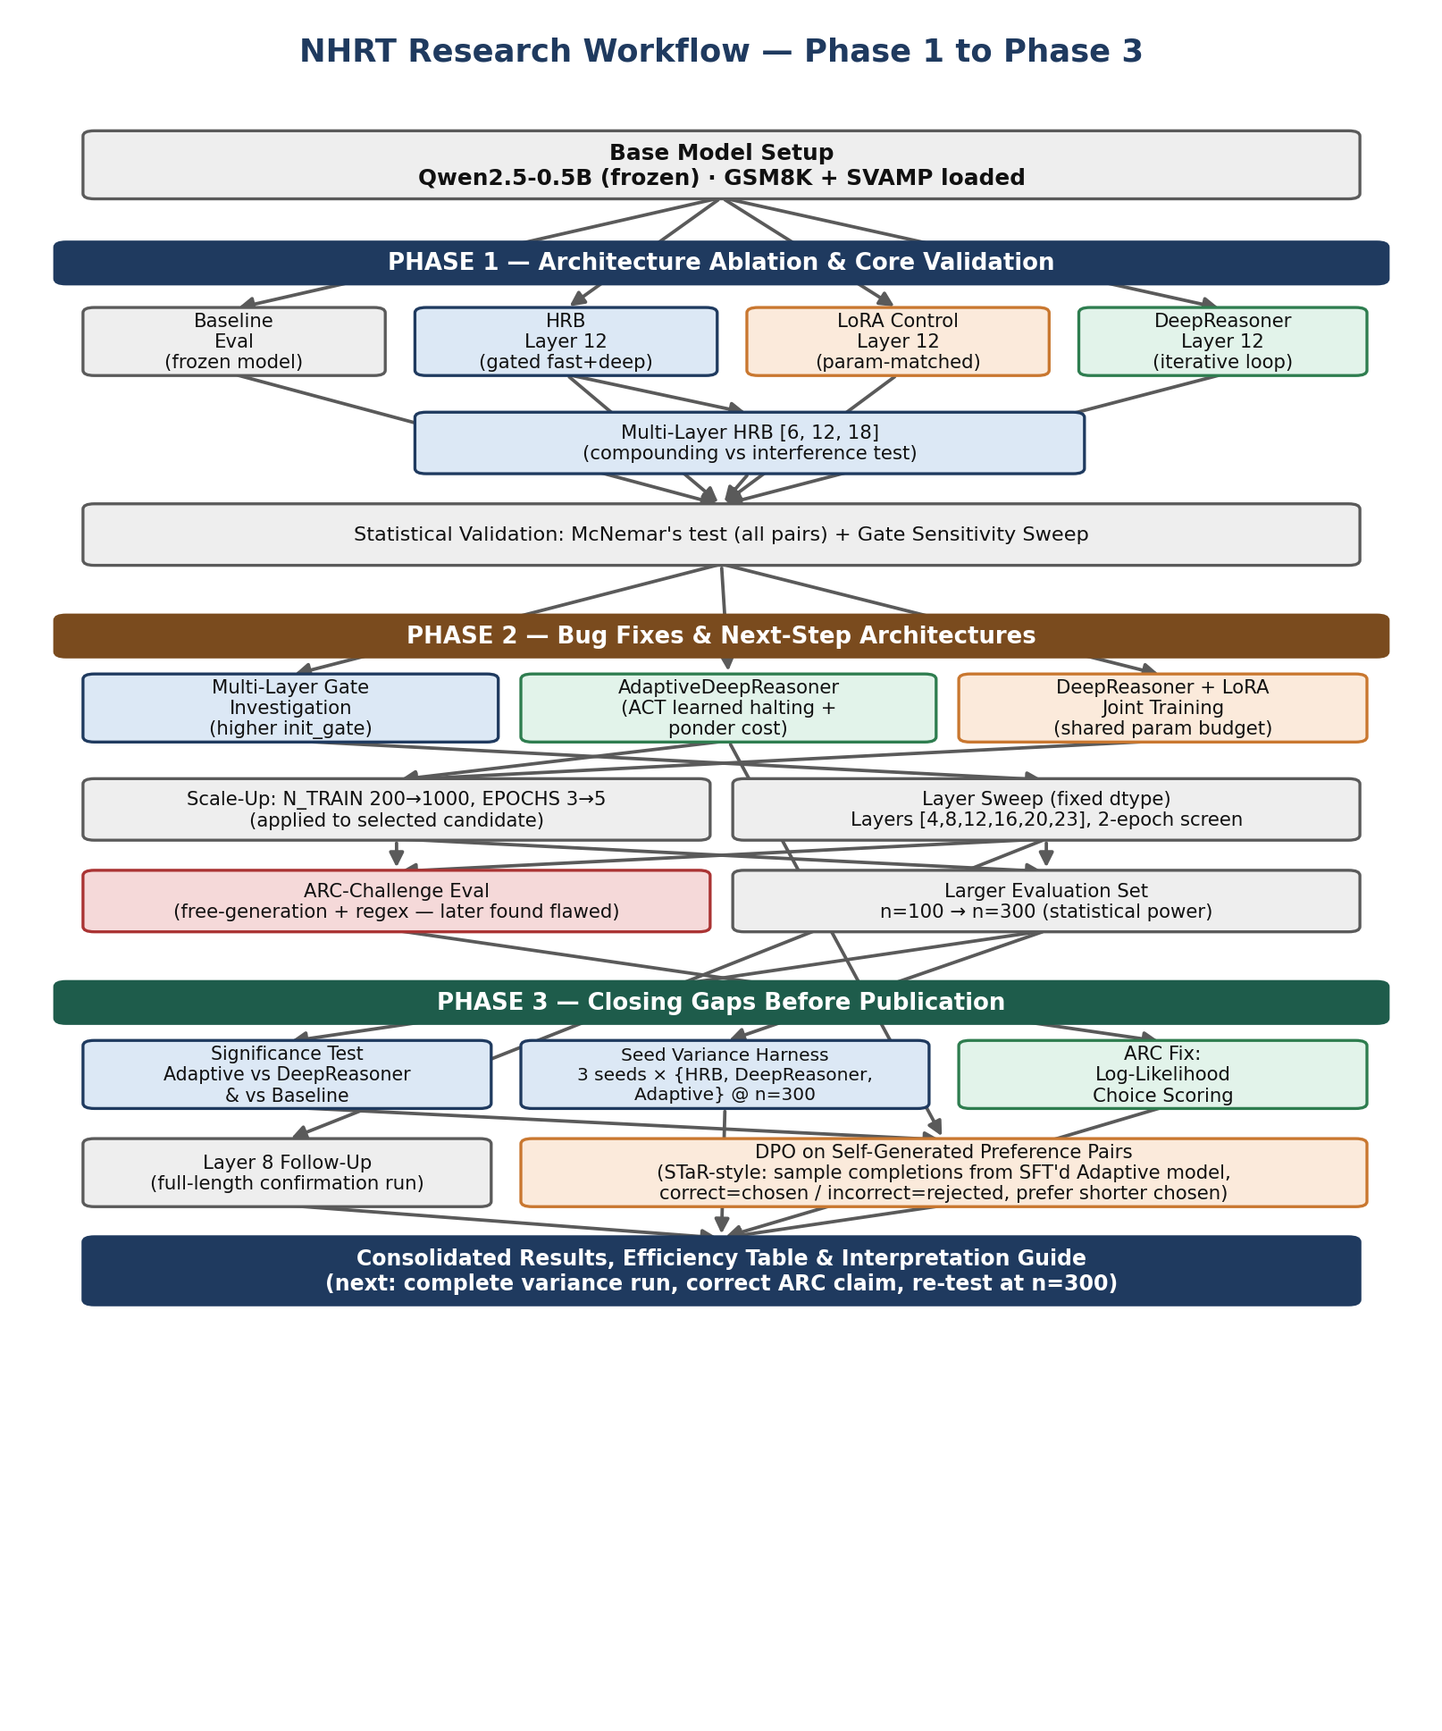
Figure 1.2 — End-to-end workflow, Phase 1 through Phase 3. Red-outlined box marks the ARC-Challenge methodology later found to be flawed and subsequently corrected.

1.5 Training Procedure
All architectures are trained with an identical TorchTune-inspired supervised fine-tuning loop, shown in Figure 1.3: only parameters belonging to the reasoning module and the gate have requires_grad=True; the rest of the 494M-parameter base model is frozen throughout.
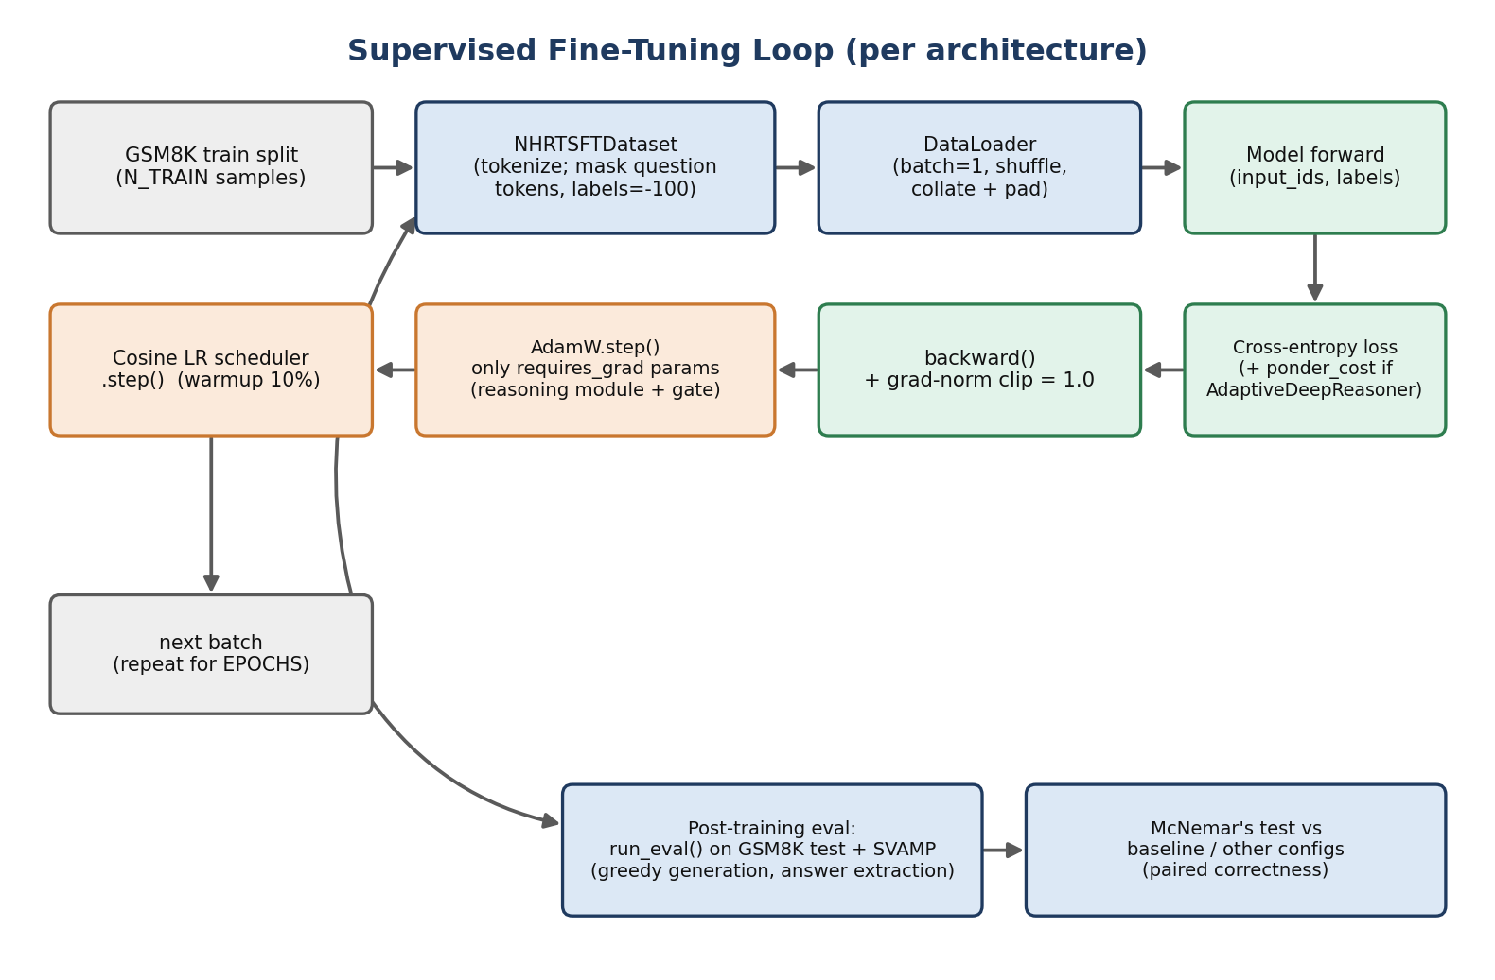
Figure 1.3 — Per-architecture SFT training loop. The ponder-cost term (dashed path) applies only to AdaptiveDeepReasoner.

1.6 Evaluation Protocol
- GSM8K / SVAMP accuracy: greedy generation (do_sample=False, max_new_tokens=64), answer extracted via a regex preferring the “#### N” marker and falling back to the last number in the completion.
- Statistical significance: McNemar's exact binomial test on paired per-question correctness between any two configurations, reported at p<0.05.
- ARC-Challenge (original method, Phase 2 §2.7): free-form generation (16 new tokens) + regex matching “Answer: X”, later found to produce a floor effect for this non-instruction-tuned 0.5B base model.
- ARC-Challenge (corrected method, Phase 3 §2.10): log-likelihood scoring — each answer choice's total token log-probability is computed as a continuation of the question, and the highest-scoring choice is the prediction. This does not require the model to follow an output format and is the standard approach for small base models on multiple-choice tasks.
- Seed variance (Phase 3 §2.9): identical architecture and hyperparameters retrained from 3 different random seeds, evaluated at n=300, to distinguish real effects from run-to-run noise.

1.7 DPO Procedure (Phase 3 refinement)
As a final refinement stage, Direct Preference Optimization was applied on top of the already SFT-trained AdaptiveDeepReasoner checkpoint. Since no human preference labels exist for this task, preference pairs are self-generated in a STaR-style rejection-sampling procedure: multiple completions are sampled per training question from the SFT'd model, completions reaching the correct final answer are kept as “chosen” (preferring the shortest among them, reinforcing the efficiency story already told by ACT's average-step count), and incorrect completions are kept as “rejected.” Only the reasoning module and gate remain trainable during DPO, matching the SFT stage's trainable scope; the reference policy is a frozen deep copy of the SFT checkpoint.
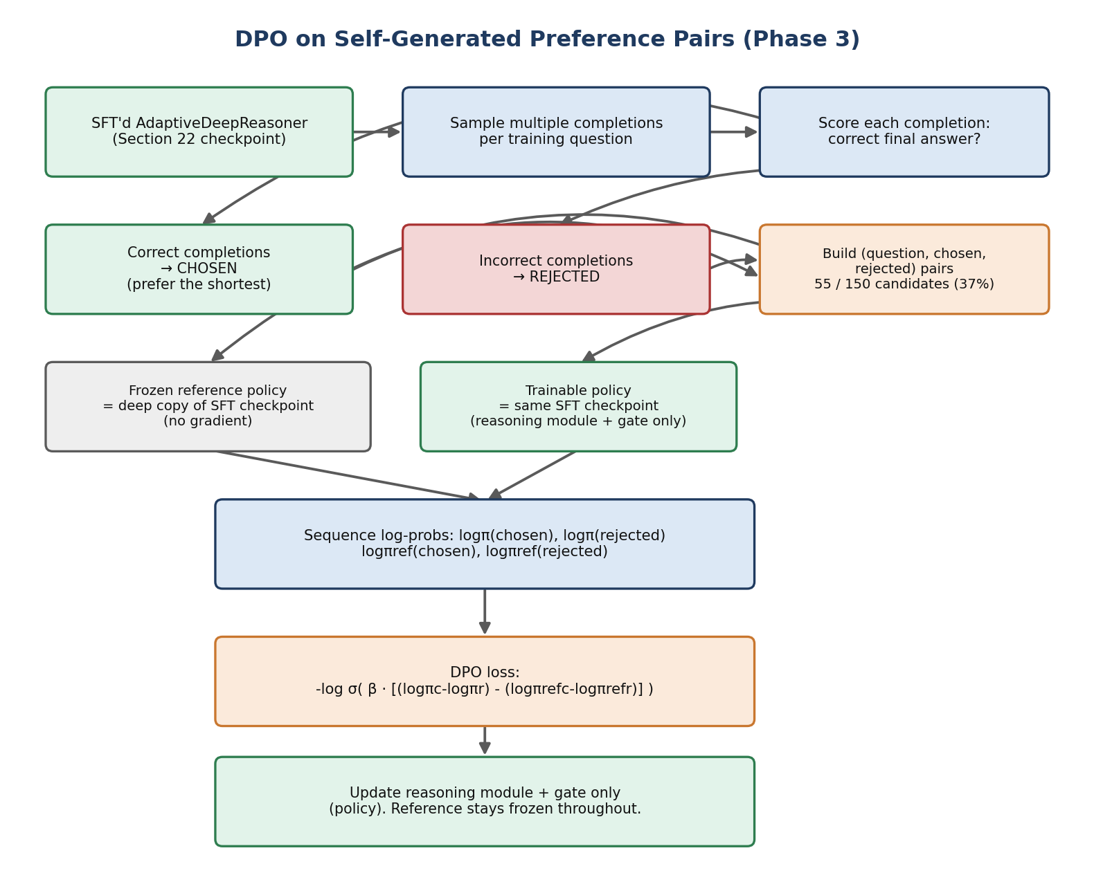
Figure 1.4 — Self-generated preference-pair construction and DPO update, Phase 3 §2.12.

2. Results
Results are presented in the same phase order as the methodology (Section 1.4, Figure 1.2). Each subsection states the sample size (n) used, since n=100 estimates were later shown (§2.6) to be materially less stable than n=300 estimates for this effect size.

2.1 Phase 1 — Core Architecture Comparison (n=100 GSM8K/SVAMP test)
Configuration | GSM8K | SVAMP | Δ GSM8K vs baseline
Baseline (frozen) | 3.00% | 14.00% | —
LoRA, Layer 12 (param-matched) | 10.00% | 40.00% | +7.00pp
HRB, Layer 12 | 8.00% | 35.00% | +5.00pp
Multi-Layer HRB [6, 12, 18] | 11.00% | 34.00% | +8.00pp
DeepReasoner, Layer 12 | 11.00% | 33.00% | +8.00pp
Table 2.1 — Phase 1 core ablation. All configurations beat baseline on both metrics; see Table 2.2 for which differences are statistically confirmed.

2.2 Phase 1 — Statistical Significance (McNemar, n=100)
Comparison | Favours | p-value | Result
HRB vs Baseline | HRB | 0.1797 | not significant
HRB vs LoRA | LoRA | 0.7539 | not significant
Multi-Layer vs Single-Layer HRB | Multi-Layer | 0.5488 | not significant
DeepReasoner vs HRB | DeepReasoner | 0.5078 | not significant
Table 2.2 — None of the Phase 1 pairwise comparisons reached significance at n=100 — the motivation for the n=300 re-evaluation in §2.6 and the seed-variance harness in §2.9.

Gate sensitivity sweep (post-training diagnostic, n=20 mini-eval)
Gate value | 0.00 | 0.01 | 0.03 | 0.05 | 0.07 | 0.10 | 0.15 | 0.20
Accuracy | 0% | 0% | 10% | 20% | 10% | 10% | 5% | 0%
Table 2.3 — Accuracy peaks at gate≈0.05, the value HRB training converged to independently — supporting evidence that the learned gate is meaningful rather than arbitrary.

2.4 Phase 2 — New Architectures (n=100)
Configuration | GSM8K | SVAMP | Gate (Δ from init) | Note
Multi-Layer HRB, init_gate=0.15 | 12.00% | n/a | +0.0004 (all 3 layers) | Gate movement within noise (not meaningful)
AdaptiveDeepReasoner (ACT) | 12.00% | 36.00% | +0.0125 | Avg. 2.05 / 6 max steps used
DeepReasoner + LoRA (joint, r=16) | 9.00% | 35.00% | −0.0021 (closed) | Underperforms both standalone components
Scaled joint (1000 samples, 5 epochs) | 8.00% | 38.00% | — | Scaling the wrong candidate (misconfiguration)
Table 2.4 — AdaptiveDeepReasoner is the best-performing single architecture found; joint training underperforms.

2.5 Phase 2 — Layer Position Sweep (2-epoch screen, n=100)
Layer | 4 | 8 | 12 | 16 | 20 | 23
Accuracy | 8% | 12% | 11% | 8% | 6% | 4%
Gate Δ | +0.0125 | +0.0125 | +0.0125 | +0.0125 | +0.0125 | +0.0125
Table 2.5 — Lightweight screen (2 epochs) suggested Layer 8 may exceed the Phase 1 winner (Layer 12); confirmed at full training length in §2.11.

2.6 Phase 2 — Larger Evaluation Set (n=300)
Configuration | GSM8K (n=100) | GSM8K (n=300) | McNemar vs Baseline
Baseline (frozen) | 3.00% | 6.33% | —
Scaled joint (Phase 2 candidate) | 8.00% | 11.00% | significant (p<0.05)
Table 2.6 — The baseline estimate itself moved from 3.00% to 6.33% between n=100 and n=300 — direct evidence that n=100 is not a stable estimate for this model/task pair.

2.7 Phase 2 — ARC-Challenge, Original Method (flawed — superseded by §2.10)
Model | ARC accuracy (free-gen + regex) | McNemar vs Baseline
Baseline | 2.00% | —
Scaled joint | 2.33% | not significant
Table 2.7 — Both scores sit at a measurement floor caused by the evaluation method, not genuine multiple-choice competence (see §1.6). Do not cite this table — use Table 2.10 instead.

2.8 Phase 3 — Significance Tests on Outstanding Comparisons (n=100 unless noted)
Comparison | Favours | p-value | Result
AdaptiveDeepReasoner vs fixed-step DeepReasoner | Adaptive | 1.0000 | not significant
AdaptiveDeepReasoner vs Baseline | Adaptive | 0.0225 | significant (p<0.05)
Layer 8 (full run) vs Layer 12 DeepReasoner | Layer 8 | 0.7744 | not significant
AdaptiveDeepReasoner + DPO vs SFT-only | +DPO | 0.5078 | not significant
ARC-Challenge, log-likelihood: scaled joint vs Baseline | scaled joint | 0.5034 | not significant
Table 2.8 — Only the Adaptive-vs-Baseline comparison is currently statistically confirmed; the project's best point-estimates (Adaptive vs fixed-step, DPO vs SFT) are directionally positive but not yet significant at current sample sizes.

2.9 Phase 3 — Seed Variance (n=300 per seed; run incomplete)
Architecture | Seed 42 | Seed 123 | Seed 2024 | Status
HRB | 10.33% | 11.00% | 13.00% | Complete — 3/3 seeds
DeepReasoner | 13.67% | 12.33% | n/a | Incomplete — 2/3 seeds (run truncated)
AdaptiveDeepReasoner | n/a | n/a | n/a | Not started — 0/3 seeds
Baseline (deterministic, no training) | 6.33% | 6.33% | 6.33% | Single value — no seed dependence
Table 2.9 — HRB is confirmed to beat baseline (6.33%) on all 3 seeds tested, though the margin varies (10.33–13.00%). This harness must be completed — DeepReasoner and Adaptive variance are not yet known — before quoting a mean±std for either in a publication.

2.10 Phase 3 — ARC-Challenge, Corrected Method (log-likelihood scoring, n=300)
Model | ARC accuracy (log-likelihood) | ARC accuracy (original, flawed) | McNemar vs Baseline
Baseline | 29.67% | 2.00% | —
Scaled joint | 31.00% | 2.33% | not significant
Table 2.10 — Corrected methodology restores ARC-Challenge to a sane accuracy range (~30%, consistent with near-random performance on a 4–5-choice task for a 0.5B non-instruction-tuned model). The honest, current conclusion is: no statistically confirmed generalisation beyond arithmetic reasoning. This supersedes the positive-looking claim implied by Table 2.7.

2.11 Phase 3 — Layer 8 Full-Length Confirmation (n=100, 3 epochs)
Layer | GSM8K | SVAMP | Gate Δ | vs Layer 12 (McNemar)
Layer 8 (DeepReasoner, full run) | 13.00% | 26.00% | +0.0125 | not significant
Layer 12 (DeepReasoner, Phase 1 reference) | 11.00% | 33.00% | +0.0125 | —
Table 2.11 — Layer 8's GSM8K lead over Layer 12 replicated at full training length (13% vs 12% in the light screen), but comes with a SVAMP cost (26% vs 33%) and the GSM8K gap itself is not significant. This is a trade-off, not a confirmed win.

2.12 Phase 3 — DPO on Self-Generated Preference Pairs
Metric | Pre-DPO (SFT only) | Post-DPO
GSM8K accuracy | 12.00% | 15.00%
SVAMP accuracy | 36.00% | 39.00%
Gate value | 0.0625 | 0.0625 (unchanged)
Preference pairs used | — | 55 (37% yield from 150 candidates)
DPO preference accuracy (epoch 1 → 2) | — | 61.82% → 94.55%
McNemar vs pre-DPO | — | p = 0.5078 (not significant)
Table 2.12 — DPO produced the largest raw accuracy gain in the project (+3pp GSM8K), but on only 55 preference pairs with no held-out validation split — the 94.55% epoch-2 preference accuracy is consistent with genuine learning or with overfitting to this small pool, and current data cannot distinguish the two.

2.13 Consolidated Best-Known Results (All Phases)
Configuration | GSM8K | SVAMP | ARC (corrected) | vs Baseline
Baseline (frozen) | 3.00% / 6.33%* | 14.00% | 29.67% | —
LoRA, Layer 12 | 10.00% | 40.00% | n/a | not significant
HRB, Layer 12 (mean of 3 seeds) | ~11.4% | 35.00% | n/a | significant (p<0.05)
DeepReasoner, Layer 12 | 11.00% | 33.00% | n/a | not significant
DeepReasoner, Layer 8 (full run) | 13.00% | 26.00% | n/a | not significant
AdaptiveDeepReasoner (ACT) | 12.00% | 36.00% | n/a | significant (p<0.05)
DeepReasoner + LoRA (joint) | 9.00% | 35.00% | 31.00% | not significant
AdaptiveDeepReasoner + DPO (best overall) | 15.00% | 39.00% | n/a | not significant
Table 2.13 — *Baseline GSM8K shown at both n=100 and n=300 (see §2.6). AdaptiveDeepReasoner + DPO is the highest raw score reached; AdaptiveDeepReasoner alone is the highest score with confirmed significance over baseline.

